Strongswan 官方配置
https://www.strongswan.org/testing/testresults/ikev2/ip-two-pools/index.html
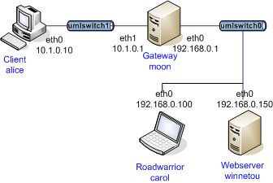
Alice
swanctl 配置文件
connections {

home {
local_addrs = 10.1.0.10
remote_addrs = 10.1.0.1

local {
auth = psk
id = alice
}
remote {
auth = psk
id = moon
}
children {
home {
updown = /usr/local/libexec/ipsec/_updown iptables
esp_proposals = aes128gcm128-x25519
}
}
version = 2
proposals = aes128-sha256-x25519
}
}
secrets {
ike-alice {
id = alice
secret = 0sv+NkxY9LLZvwj4qCC2o/gGrWDF2d21jL
}
}

Carol
swanctl 配置文件
connections {

home {
local_addrs = 192.168.0.100
remote_addrs = 192.168.0.1

local {
auth = psk
id = carol
}
remote {
auth = psk
id = moon
}
children {
home {
updown = /usr/local/libexec/ipsec/_updown iptables
esp_proposals = aes128gcm128-x25519
}
}
version = 2
proposals = aes128-sha256-x25519
}
}
secrets {
ike-carol {
id = carol
secret = 0sv+NkxY9LLZvwj4qCC2o/gGrWDF2d21jL
}
}

Moon
swanctl 配置文件
connections {

rw1 {
local_addrs = 192.168.0.1
pools = pool1

local {
auth = psk
id = moon
}
remote {
auth = psk
}
children {
rw1 {
updown = /usr/local/libexec/ipsec/_updown iptables
esp_proposals = aes128gcm128-x25519
}
}
version = 2
proposals = aes128-sha256-x25519
}

rw2 {
local_addrs = 10.1.0.1
pools = pool2

local {
auth = psk
id = moon
}
remote {
auth = psk
}
children {
rw2 {
updown = /usr/local/libexec/ipsec/_updown iptables
esp_proposals = aes128gcm128-x25519
}
}
version = 2
proposals = aes128-sha256-x25519
}
}

pools {
pool1 {
addrs = 10.3.0.0/28
}
pool2 {
addrs = 10.4.0.0/28
}
}
secrets {
ike-moon {
id = moon
secret = 0sv+NkxY9LLZvwj4qCC2o/gGrWDF2d21jL
}
}

配置完成后
Alice Moon Carol分别执行
systemctl restart strongswan
swanctl --load-all

在Alice和 Carol分别执行 ipsec up home
此时隧道建立成功

